 | Maryam Daneshpazhooh <maryamdanesh.pj@gmail.com>

Reminder: 22nd EADV Congress – Online Presentation Submission
1 message

no-reply@m-anage.com <no-reply@m-anage.com> | Mon, Jul 22, 2013 at 5:01 PM
Reply-To: eadvistanbul2013@m-events.com
To: maryamdanesh.pj@gmail.com
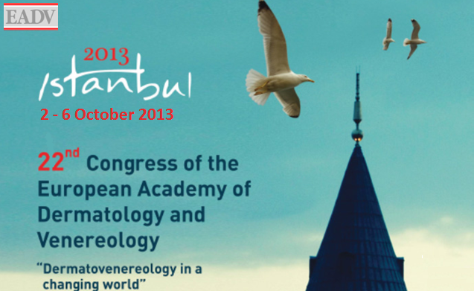
Dear Dr. Maryam Danesh Pazhouh,

You have been accepted to present an electronic poster (ePoster) at the 22nd Congress of the European Academy of Dermatology and Venereology in Istanbul, Turkey. Therefore you are invited to upload your ePoster, to a protected server of the EADV’s trusted service provider, M Events Cross Media GmbH.

Please read the following text carefully. At the end you will find the instructions for submitting your ePoster.

During the congress your ePoster will be accessible on selected computer terminals inside the venue where participants can read your presentation.

====================================================
All material must be submitted by 1st August.
====================================================
Please note that this is the last deadline. After the 1st August you will no longer be able to upload your ePoster.

Please note that your material can NOT be uploaded or hung onsite in Istanbul. If you do not upload your ePoster now, it will not be visible in the ePoster area in Istanbul.

Detailed online support is available during the upload process. For technical questions regarding your ePoster you can contact the M Events helpdesk directly at: eadvistanbul2013@m-events.com

Format for ePoster:
====================
Only material in the form of MS-PowerPoint (*.ppt and *.pptx) with a screen ratio of 4:3 and a minimum resolution of 1024x768 can be accepted. Hyperlinks, animated images, animations and animated slide transitions are not permitted for ePosters and will be non-functioning.

Please note that the maximum number of slides permitted is 6.

Internet Upload:
================
All material that you have submitted can be edited or replaced until the deadline of 1st August.
After that date, no further alterations can be made. Any material that is attached to an email cannot be processed.

Your personal direct link to your account:
login

You will receive an automated confirmation e-mail once your material has been successfully submitted.

We look forward to seeing you in Istanbul.

Kindest regards,

The EADV Abstract team & M Events Cross Media GmbH

