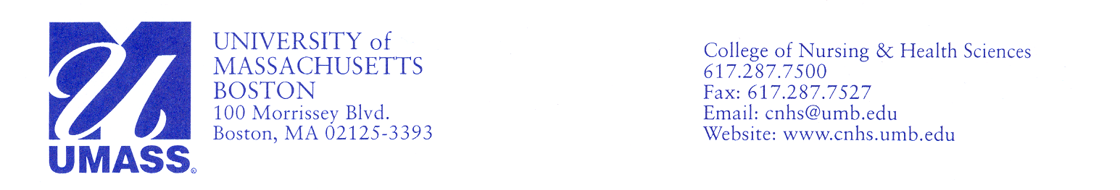

December 9, 2017

**Director, Pediatric Department**

**Faculty of Nursing and Midwifery**

**Tehran University of Medical Sciences**

**Nousrat St- Tohid Square**

**Tehran, Iran**

To Whom It May Concern

I am writing to certify that Dr. **Akram Sadat Sadat Hoseini, Assistant Professor in the Pediatric Department of the Faculty of Nursing and Midwifery at Tehran University of Medical Sciences was at the University of Massachusetts Boston as an International Visiting Scholar, from September 5, 2017 until December 15, 2017, during her sabbatical leave.**

**During the time with us, Dr. Hoseini worked closely with me, meeting for approximately one hour each week with follow-up email communication, to develop a nursing conceptual framework for Islamic culture. This conceptual framework is an important addition to existing nursing conceptual models, almost of which reflect Western Judeo-Christian perspectives of nursing. The paper about the conceptual framework was submitted to a major peer-reviewed nursing journal, *Nursing Science Quarterly*, on December 5, 2017. I am confident that the paper will be accepted for publication following peer-review.**

**Furthermore, Dr. Hoseini actively participated in our PhD Nursing Program course, NURS 750, Contemporary Nursing Knowledge, which I teach. Dr. Hoseini satisfactorily completed and did oral presentations of the three assignments for the course (one PowerPoint presentation done in collaboration with a doctoral student in the course and two individual papers). Dr. Hoseini's participation in this course substantially increased the students' and my understanding of Iranian nursing.**

**Dr. Hoseini also attended the College of Nursing and Health Sciences weekly Scholarly Dialogues, which increased her knowledge of ongoing faculty research. In addition, Dr. Hoseini visited Children's Hospital Boston and had an opportunity to observe nursing care in two pediatric intensive care units. This visit was coordinated and hosted by Dr. Jean Connor, a nurse scientist at the hospital. Dr. Hoseini also visited St. Elizabeth's hospital and had an opportunity to observe nursing care in a neonatal intensive care unit and discuss maternity and neonatal nursing care with our faculty member, Mary Ellen Jagelski, who teaches classroom and clinical components of our undergraduate maternity and women's health course. In addition, Dr. Hoseini observed an extensive simulation of pediatric nursing care in our Center for Clinical Education and Research.**

Overall, it has been a distinct pleasure to work with Dr. Hoseini throughout the semester. I learned a great deal from her about Islamic culture and appreciated all that she contributed to our Department of Nursing by her presence with us.

Most sincerely yours,



Jacqueline Fawcett, RN; PhD; ScD (hon); FAAN; ANEF

Professor, Department of Nursing